

Carroll College Room Scheduler

User Manual

Developers: Oliver Mclane, Ryan O’Valley, Hank Rugg

Updated: April 29, 2024

Our vision for this software is to provide a useful and intuitive interface for the Carroll College Registrars to access and view their course scheduling data.

Our timeline for completing this project is below.

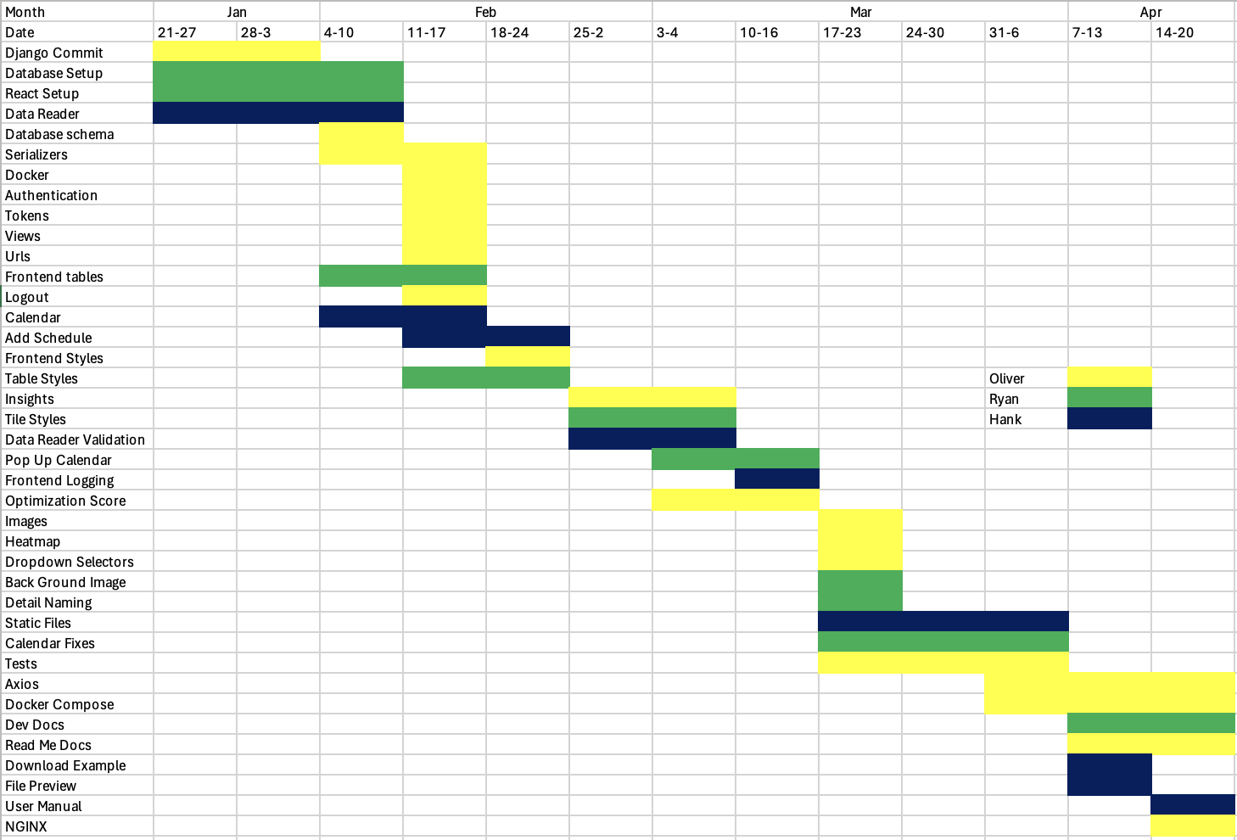

**Getting Started 4**

Sign Up 4

Login 4

**Navigation Bar 5**

Logout 6

**Dashboard 6**

Classrooms View 6

Courses View 6

Search Data 7

Export Data 8

Show Tiles 10

**Import New Term 13**

**Insights 14**

Seat Usage 15

Total Idle Time 16

Most Frequent Professors 16

Total Used Time 17

Total Seats 17

**Issues or Concerns 20**

# Getting Started



## Sign Up

When you access the website, you will see the login page. Before you are able to login, you need to register as a user. To do this, click the gray “Sign Up” button. This will bring you to the registration page where you need to enter your email, username, and password. Once you have entered this information, click “Register”.



## Login

If you have successfully registered a user, you will now be able to login. To do this, enter your email and password and click “Login”. You will be sent to the dashboard page upon a successful login.

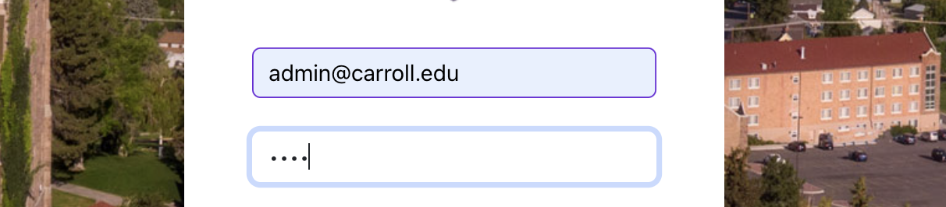

# Navigation Bar

The navigation bar is located on the left side of the page. By default, it will be minimized with clickable icons indicating each action available. To expand the bar, click the arrow at the top.



This will expand the navigation bar and make the name of each action visible.

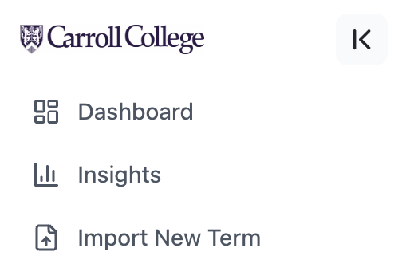

Each title will bring you to the corresponding page. By default, you will be at the Dashboard page. To minimize the navigation bar, click the button on the top right of the bar.

## Logout

Your relevant information will be displayed at the bottom of the navigation bar. To logout, expand the navigation bar and click the button on the bottom right of the bar.

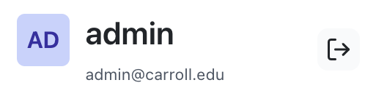

# Dashboard

The main page is the dashboard. This is where you will be able to view the rows of data, search for data, and export data.

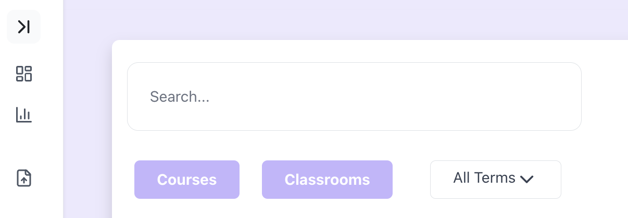

## Classrooms View

The top row of buttons has a “Courses” and “Classrooms” button. To view the classroom data such as the amount of seats, click the “Classrooms” button.

## Courses View

To view the course data, select the “Courses” button. This will display all courses in the database by default. To view by term, use the dropdown to select the term you would like to view.

## Search Data

To search through the data using the search bar, simply type what you want to search by and the results will automatically appear in the table. You can search by any relevant information.

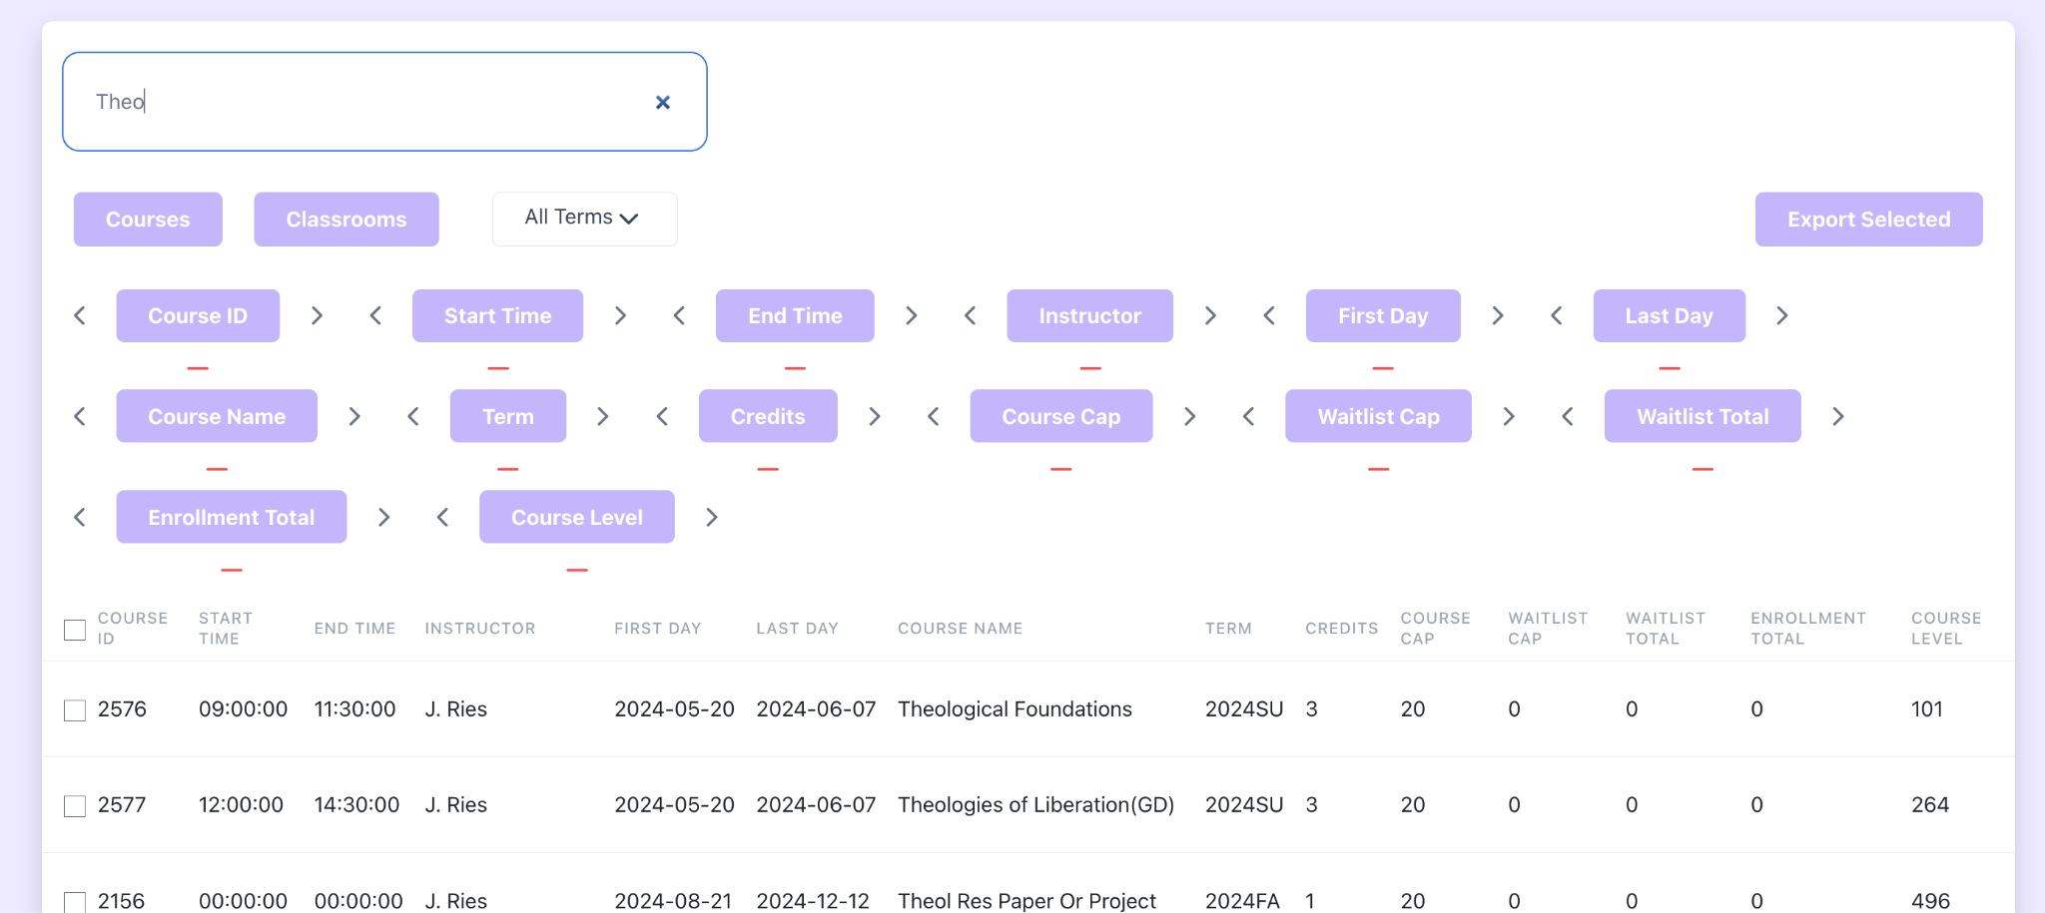

For example, if we want to search for and export the data for Nathan Williams in the fall, we can do this by searching. First start by selecting the term from the dropdown, then searching by instructor in the search bar. This will populate the table with Mr. Williams classes in Fall 2024.

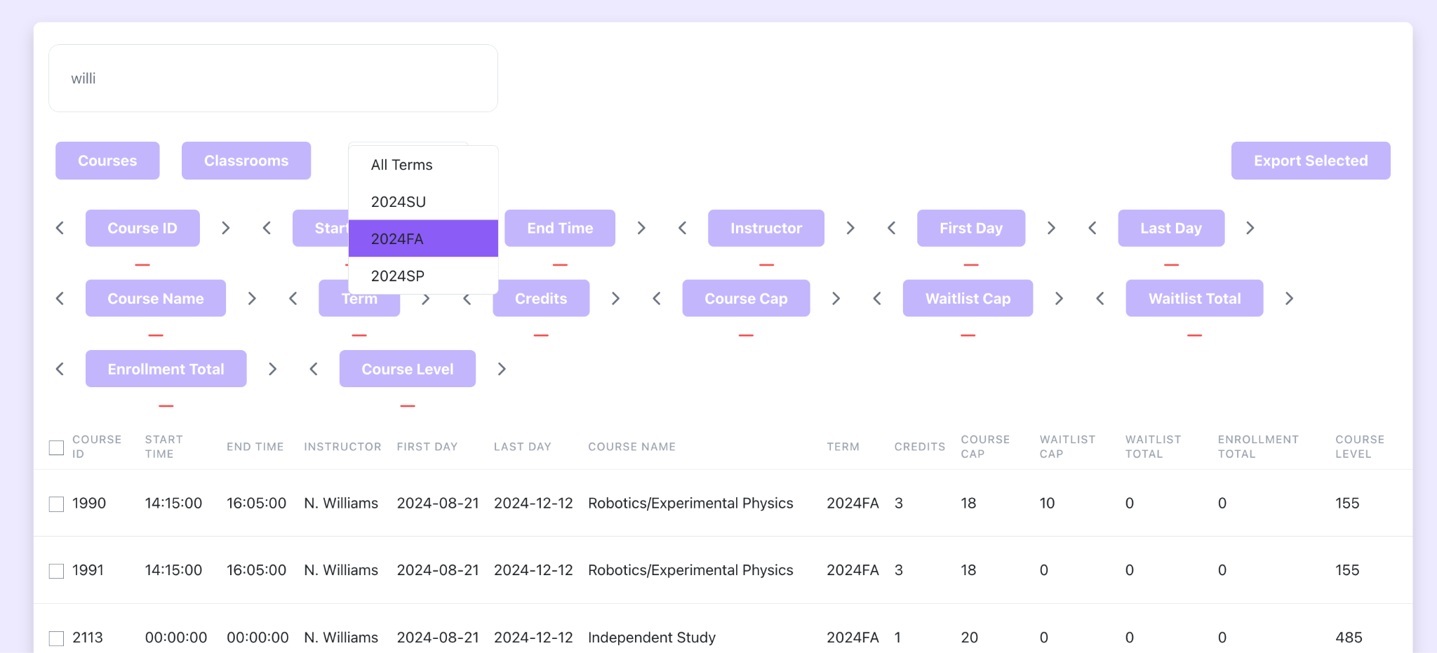

## 

## Export Data

To export all this data, select the top check box in the left side of the table.

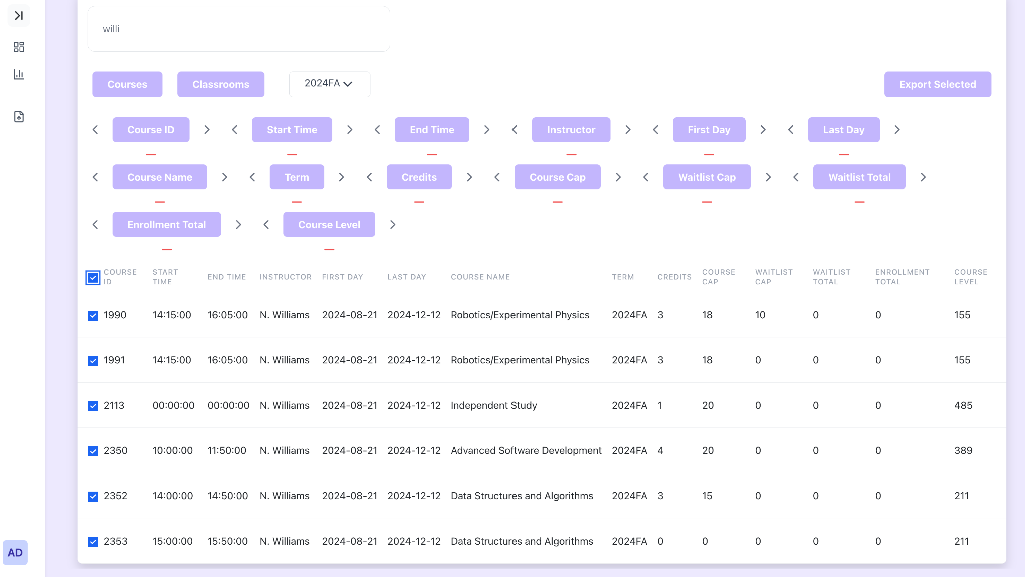

To select specific courses to export, manually select the courses to export.

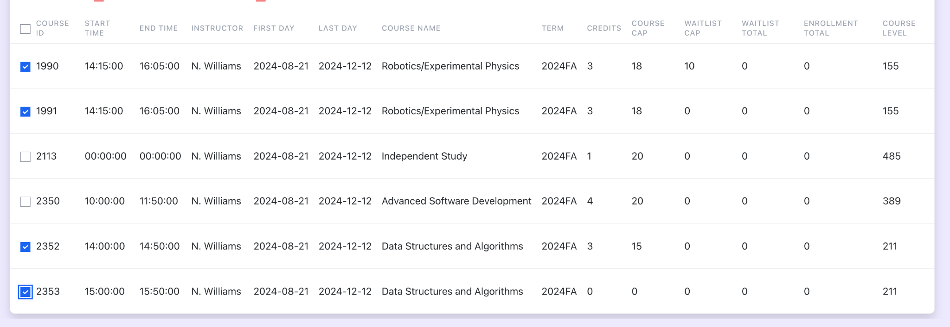

Now that the courses needed are selected, we need to order the columns. The columns of the file are organized at the top of the page in the purple buttons.

To rearrange the columns of the exported file, click the left and right arrows. Note that this will only appear on the exported schedule and not in the table below.

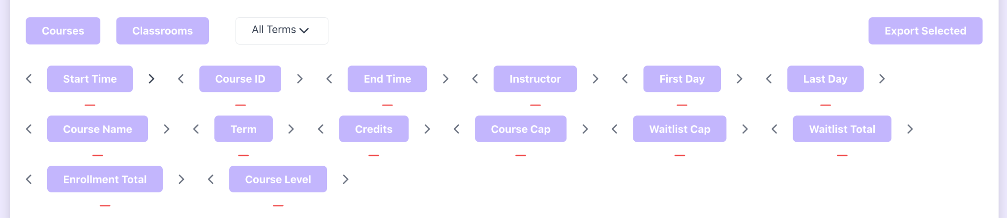

Notice now that the start time and course ID are switched after clicking the right arrow on course ID. To remove a column, click the red minus sign on the bottom of the button.

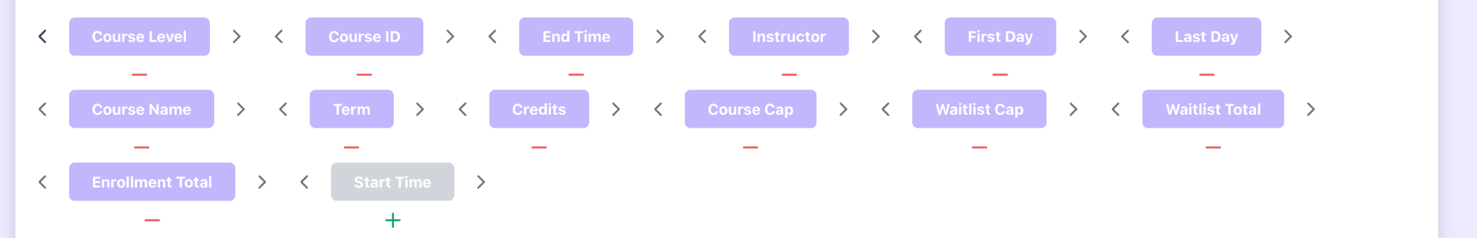

This will remove that column from the exported file and will be shown in gray to signify its absence. To add it back to the file, click the green plus sign on the bottom.

Next, once we have the columns we would like to have selected, press the purple, “Export Selected” button on the top right.

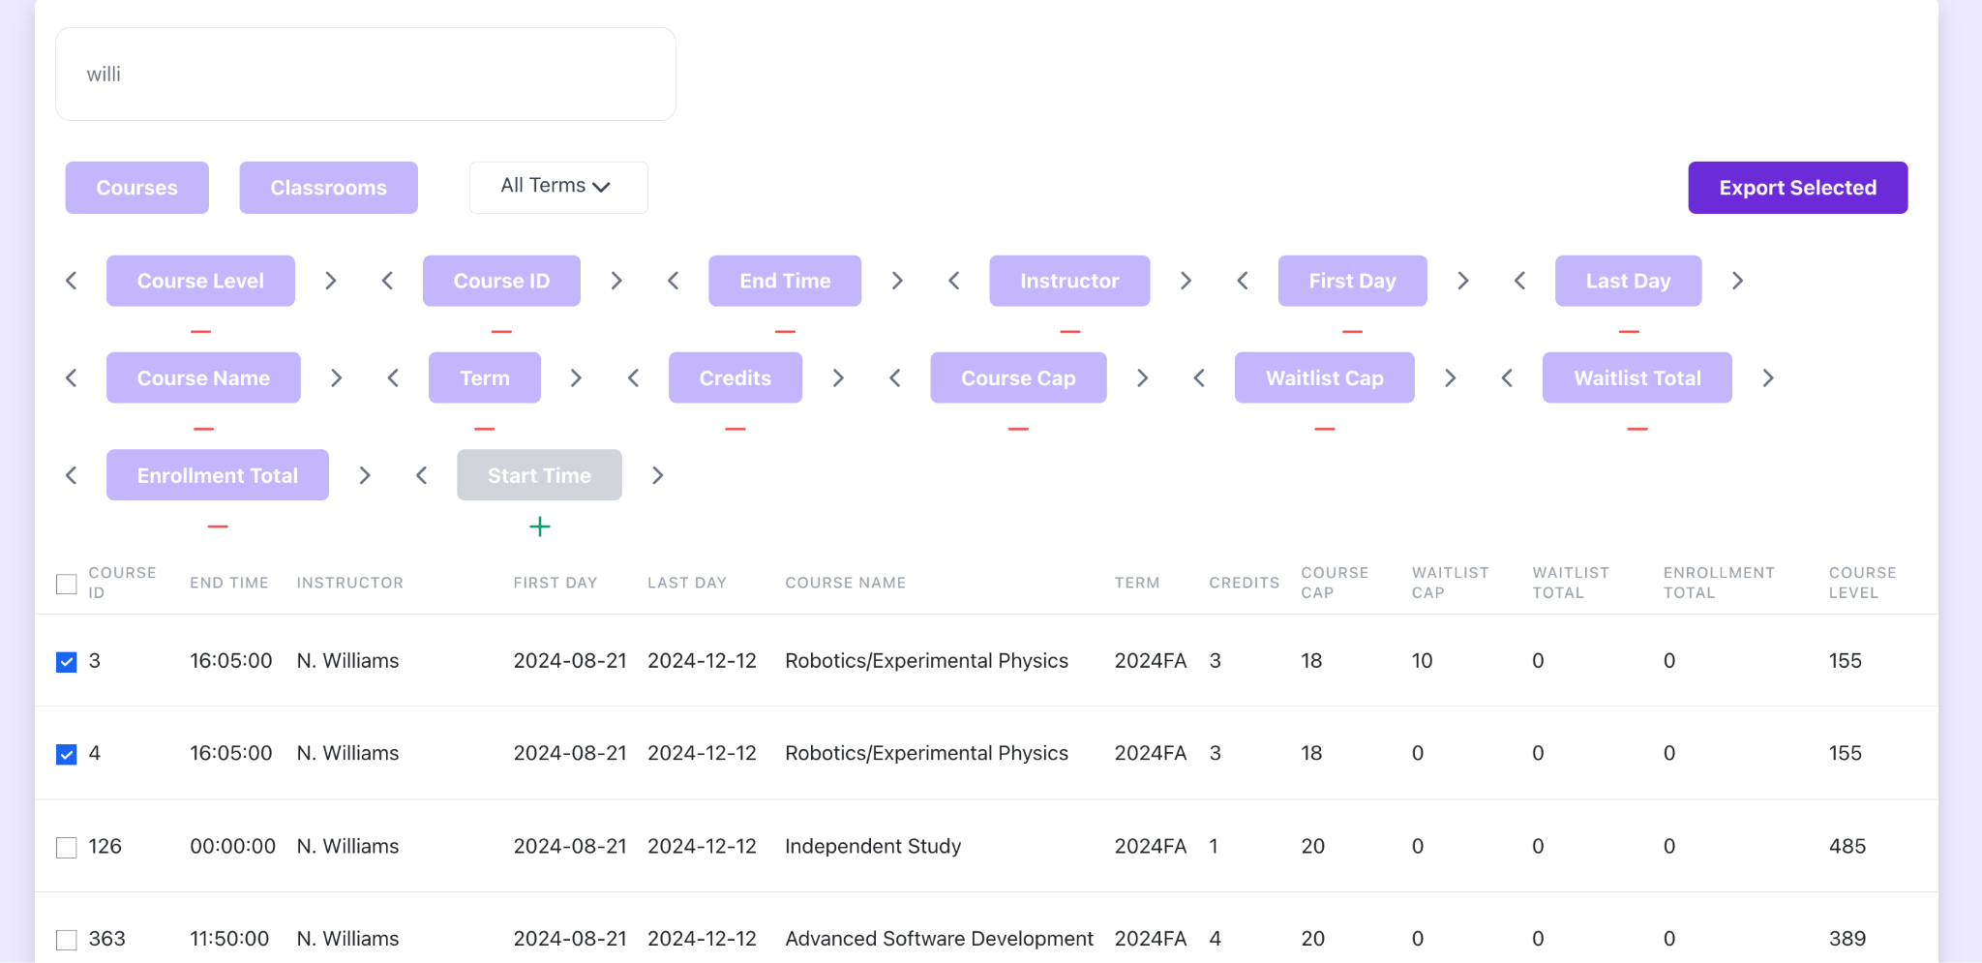

This will bring up a window where we are able to rename the file and select the format to export the file as.

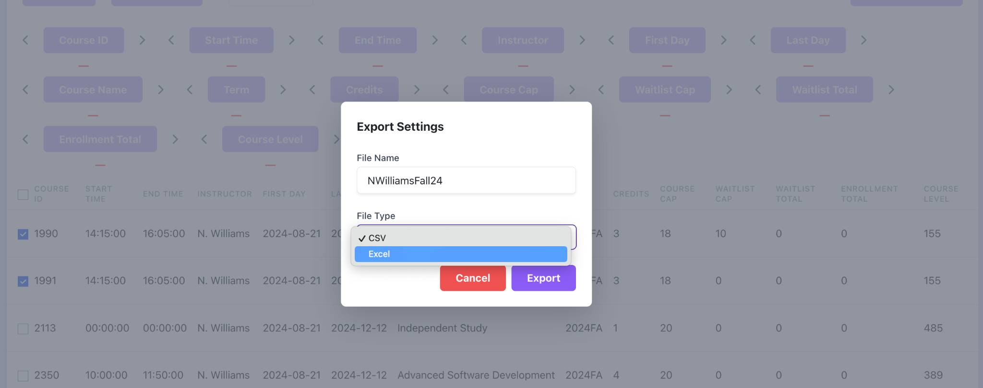

Clicking “Export” will download the file to your computer.

## Show Tiles

To view the schedule for a specific classroom, scroll to the bottom of the page and click the “Show Tiles” button in the bottom left corner.

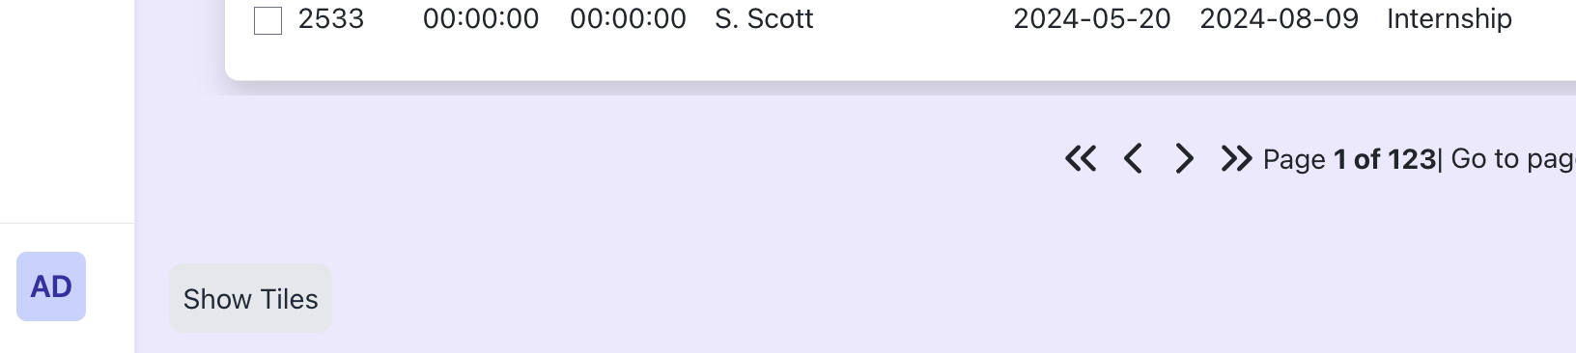

This will bring you to a new page with a list of each building that has a class in it.

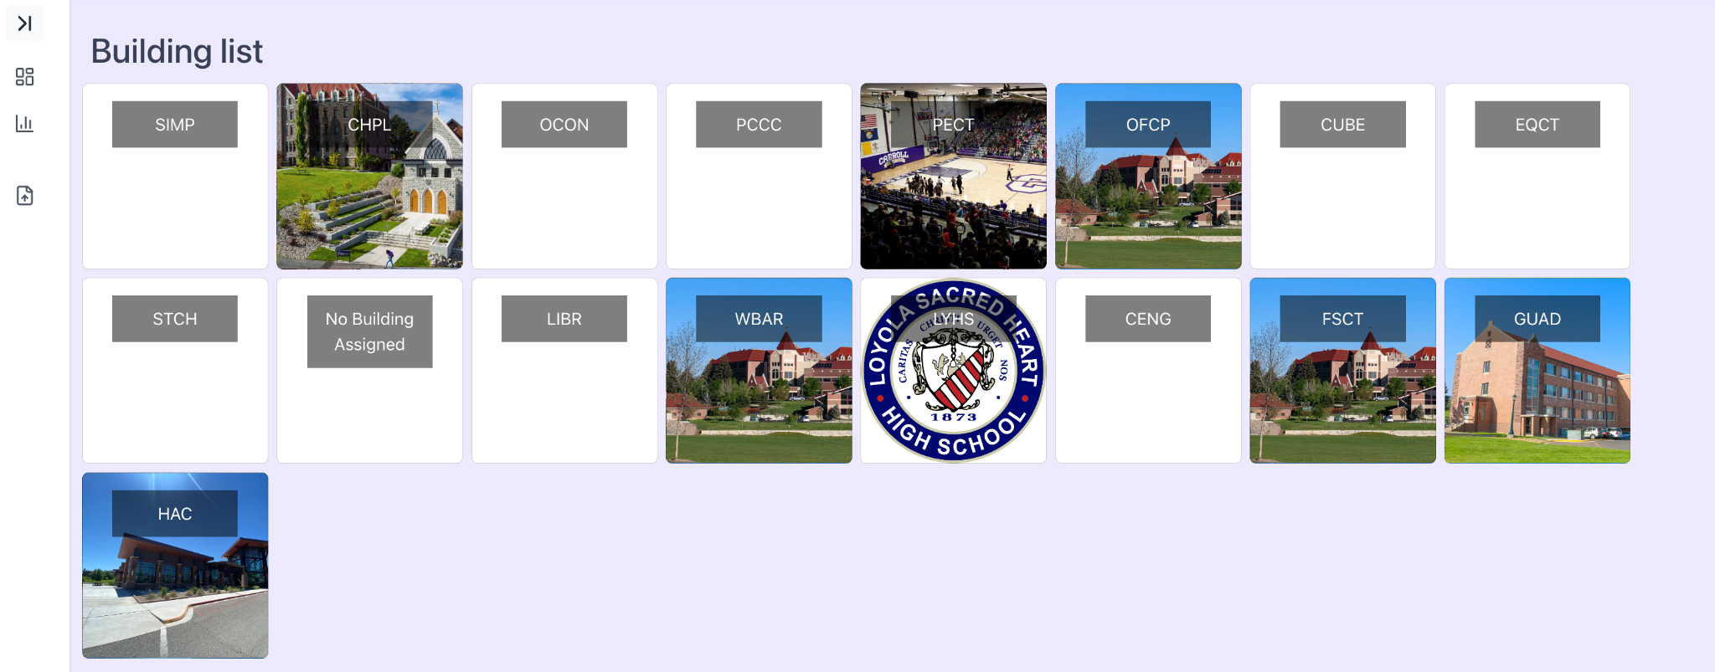

Select a building to then view the floor list for that building.

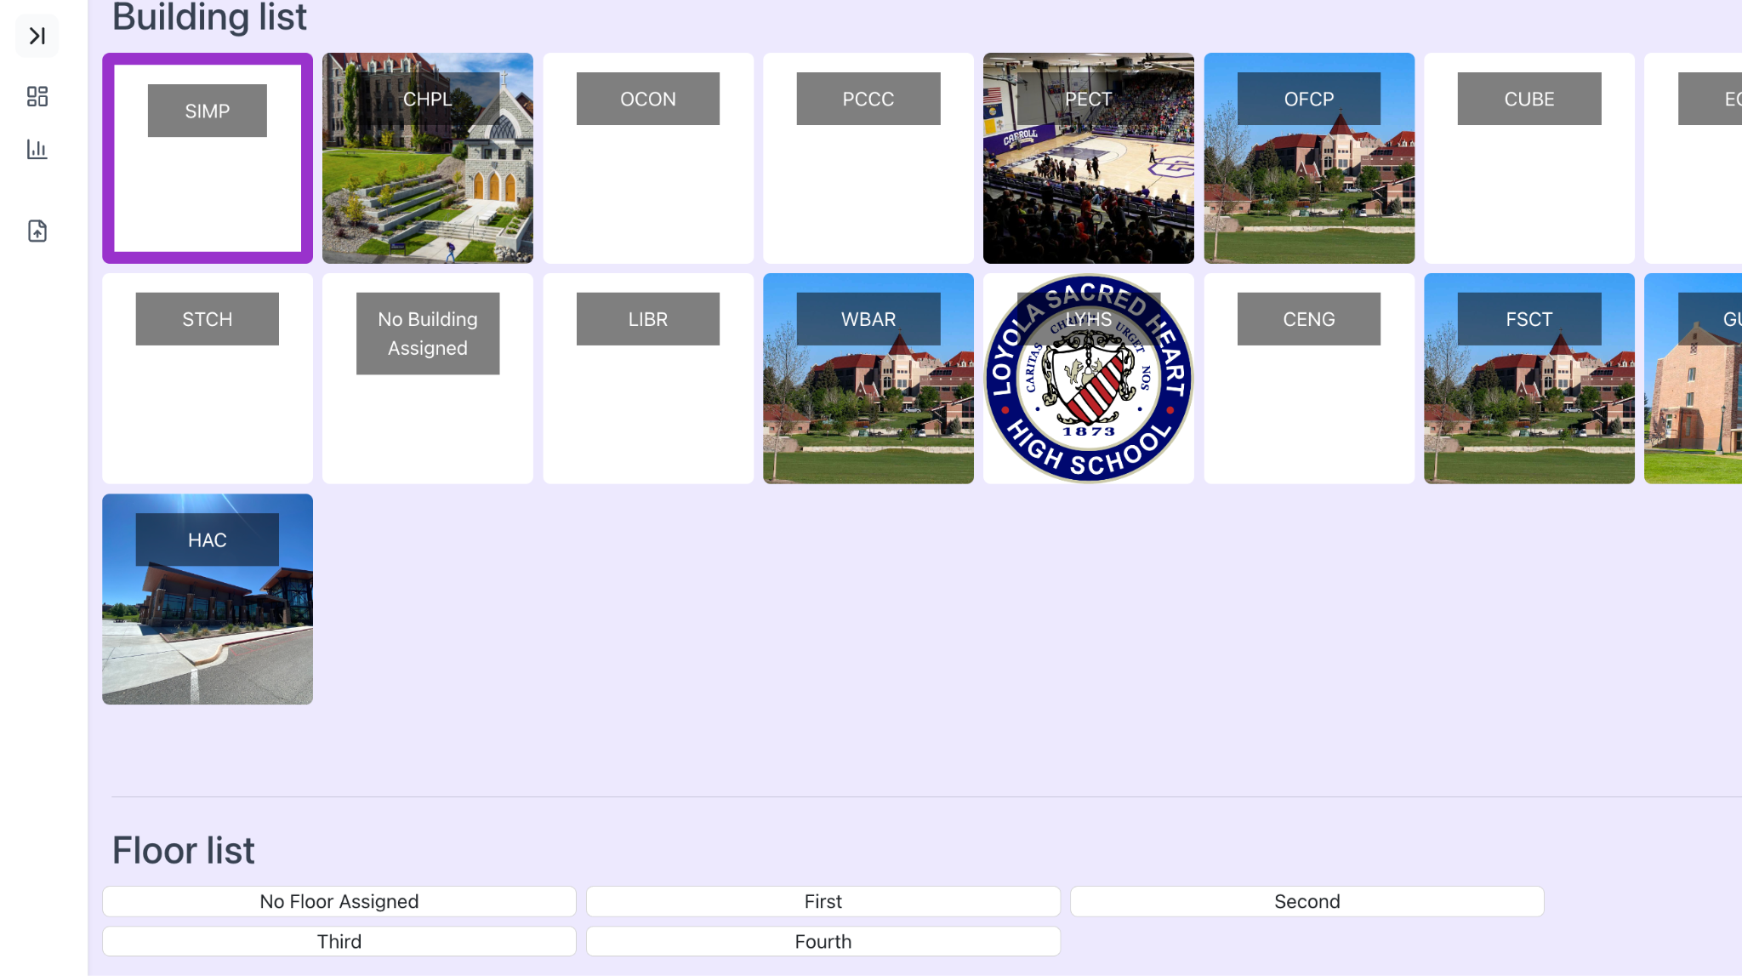

Next, select the floor that the room you're looking for is in.

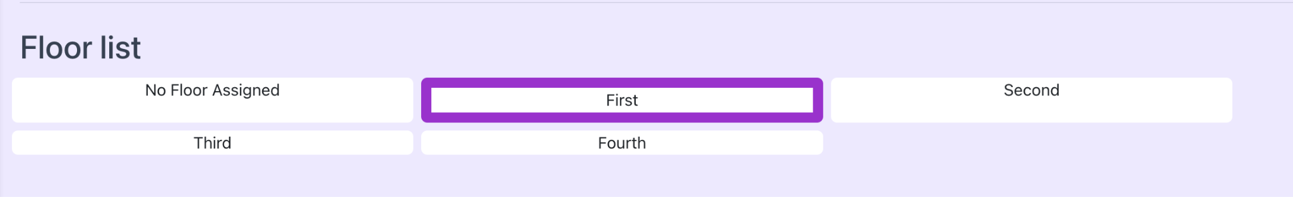

This will bring up a list of classrooms on that floor for all terms.

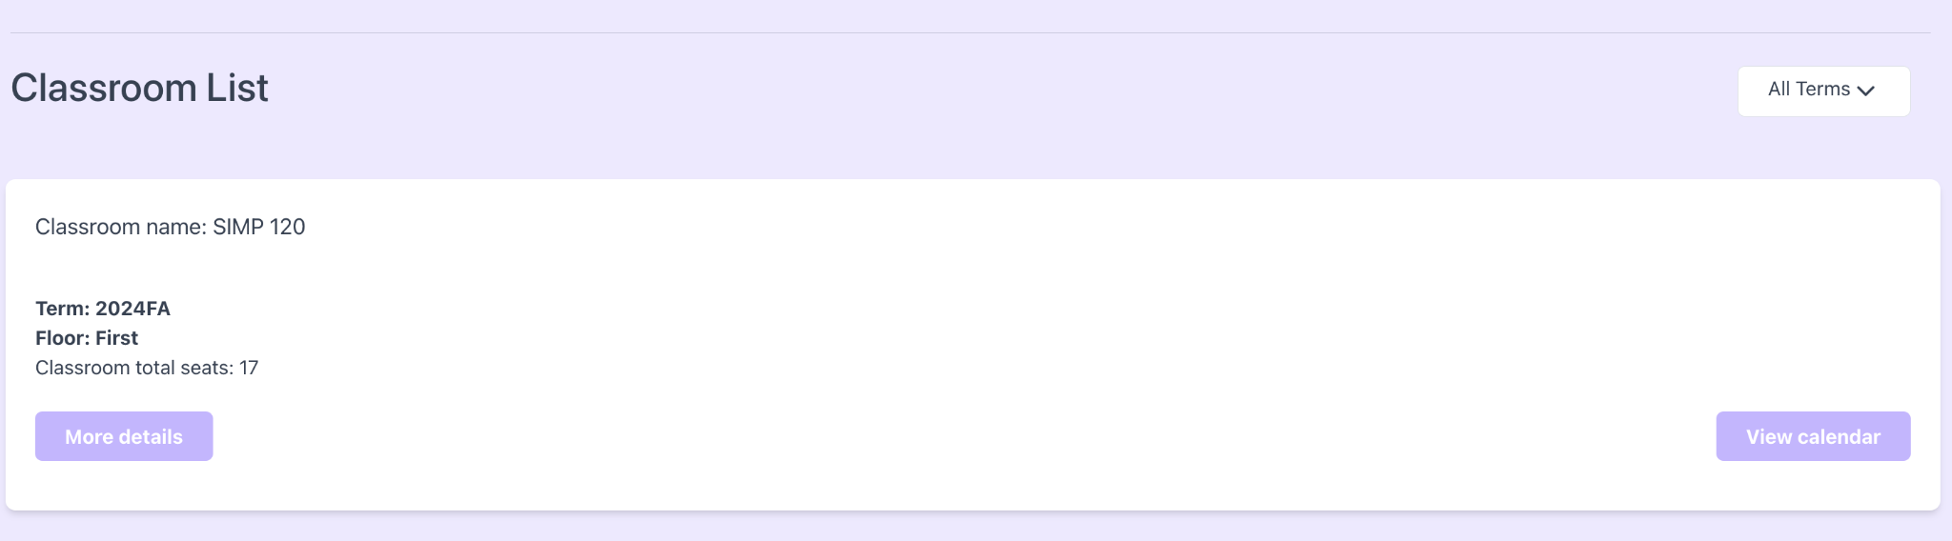

To view only classrooms for a specific term, use the dropdown in the top right corner to select the appropriate term.

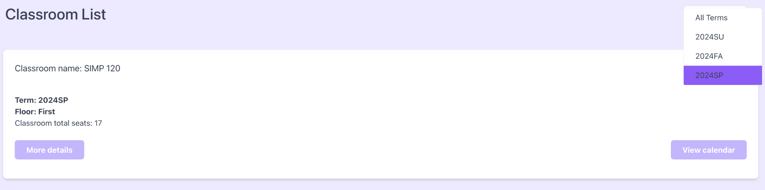

This will then filter the available classrooms to only those in the specified term.

To view more details, click the “More details” button on the bottom left.

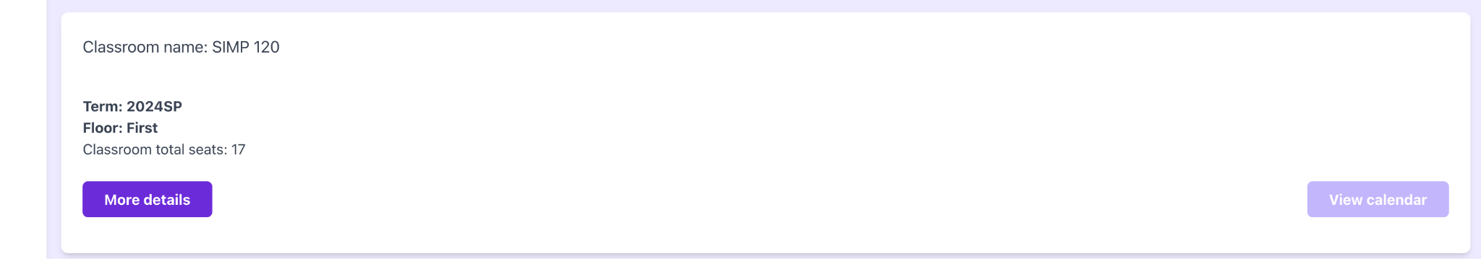

This will bring up a window outlining the details of the classroom.

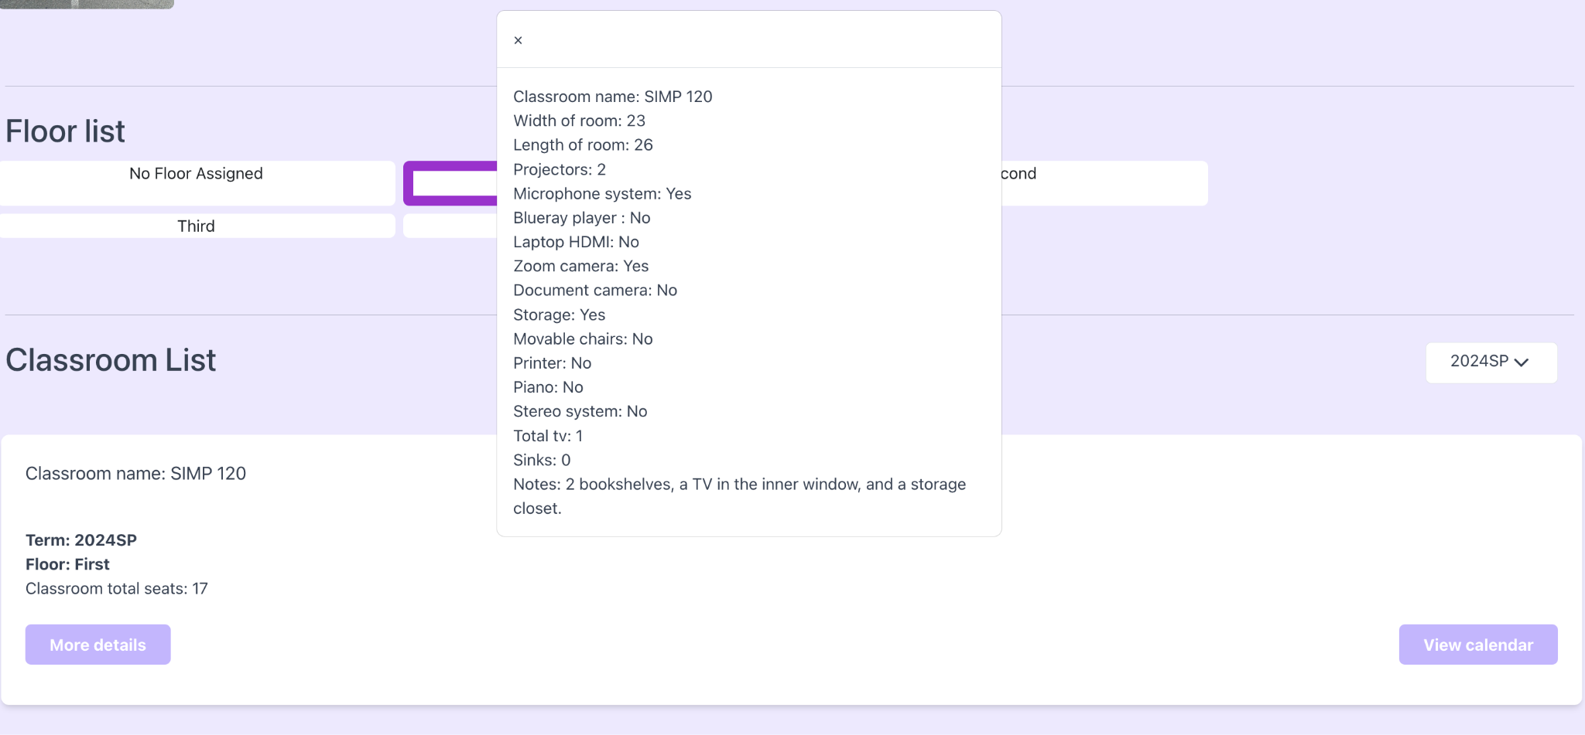

To view the calendar for that classroom, click on the “View calendar” button. This will display the schedule for that classroom in a calendar view.

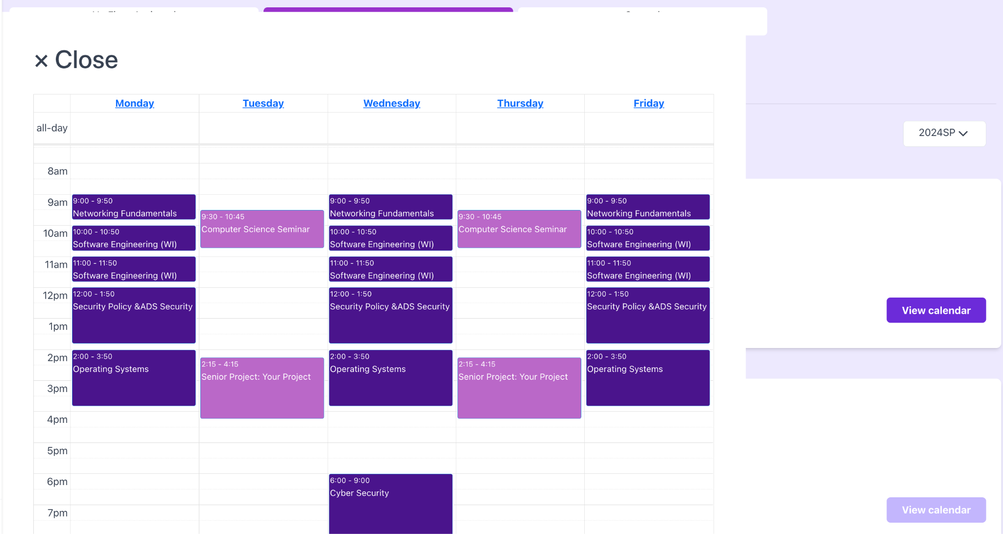

# Import New Term

Initially, there will be no data loaded into the tables. To import new data, you will need to visit the Import New Term tab.

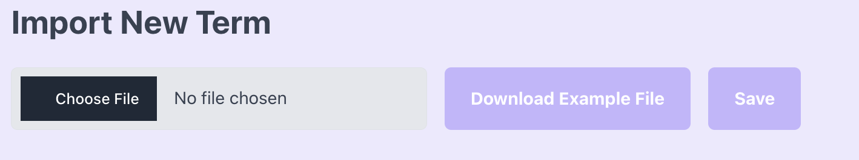

To choose a file to upload, select the “Choose File” button. This will open a file selector where you can select the Excel file you want to import. Once the file is chosen, you will be notified of any missing columns and will see a preview of the data if the file is acceptable.

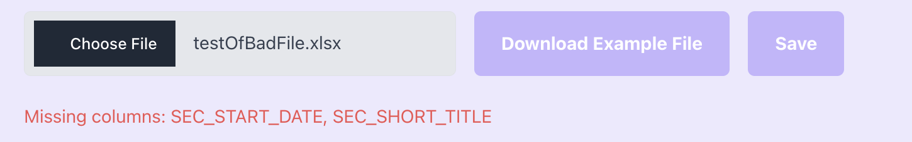

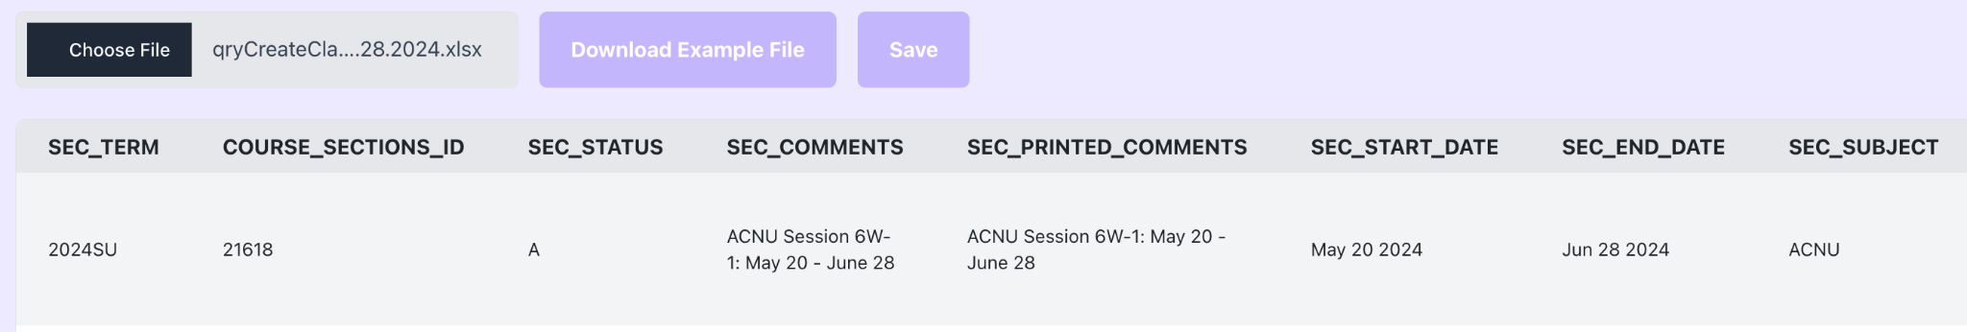

If you need to see an example of what the Excel file should look like, click the “Download Example File” button. Once you have selected an acceptable file, click the “Save” button to import the file to the database. If this is successful, you will see a file successfully uploaded button.

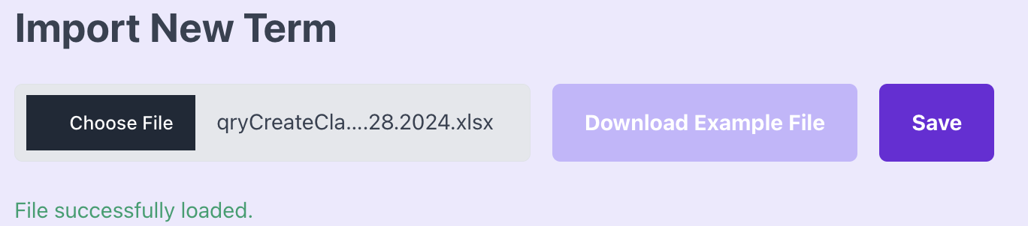

# Insights

The insights page displays the seat usage per class, total idle time, most frequent professors, amount of seat used, and total used time. These are intended to be helpful stats to facilitate easier identification of underused classrooms. To view these insights, you must select a classroom from the dropdown at the top of the page. First select the term, then the building, then the classroom.

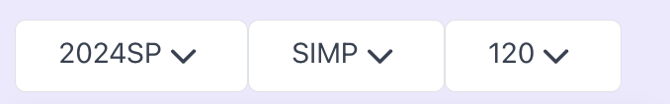

This will populate the insights with information on that classroom.

## Seat Usage

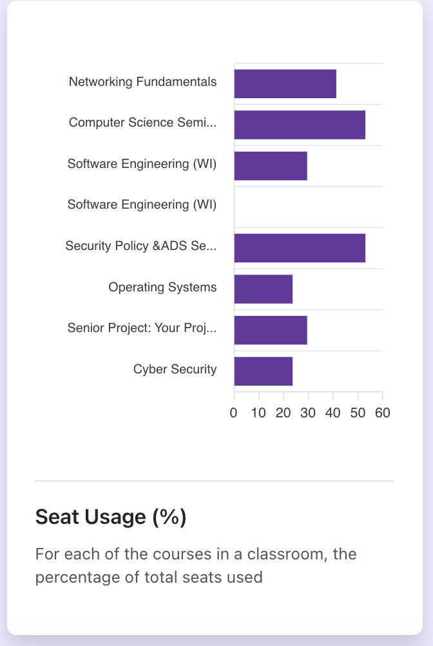

The first insight is the Seat Usage. This shows the percentage of seats that are filled in that classroom, per class. For example, networking fundamentals has 41% of the seats used.

## 

## Total Idle Time

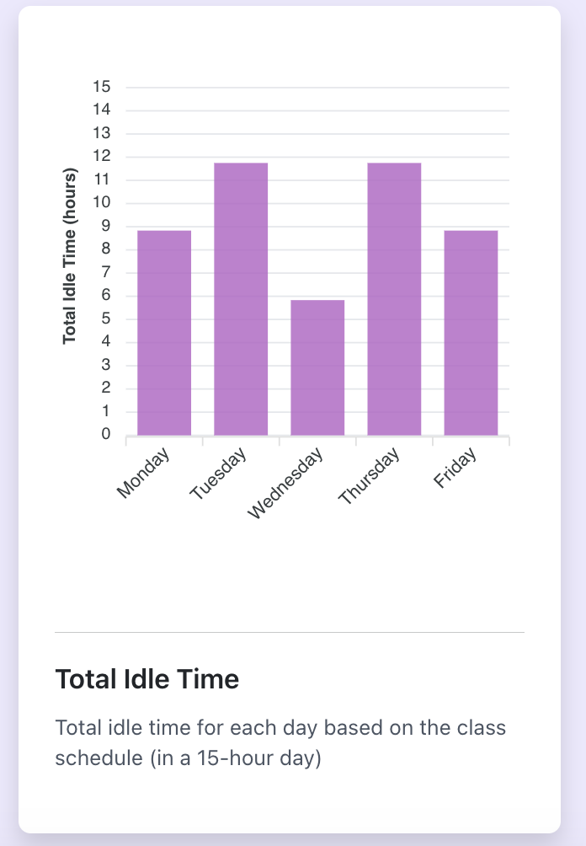

The next insight is Total Idle Time. This insight shows the amount of time per day the classroom is not being used. This is the time in aggregate, and the specific times the room is not being used is shown further down the page.

## Most Frequent Professors

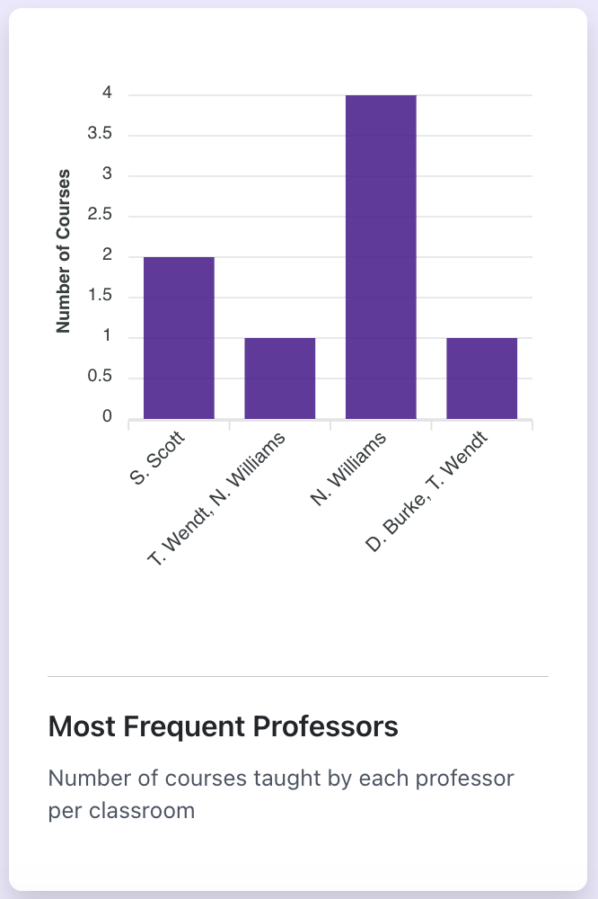

The third insight is Most Frequent Professors. This shows the amount of classes each professor teaches in that classroom.

## Total Used Time

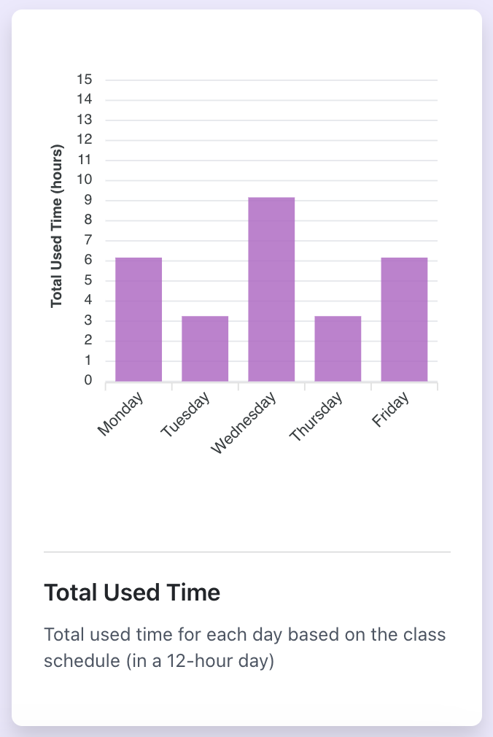

The next insight is the Total Used Time. This shows the total amount of time the classroom is used. It is showing the opposite of the Total Idle Time.

## Total Seats

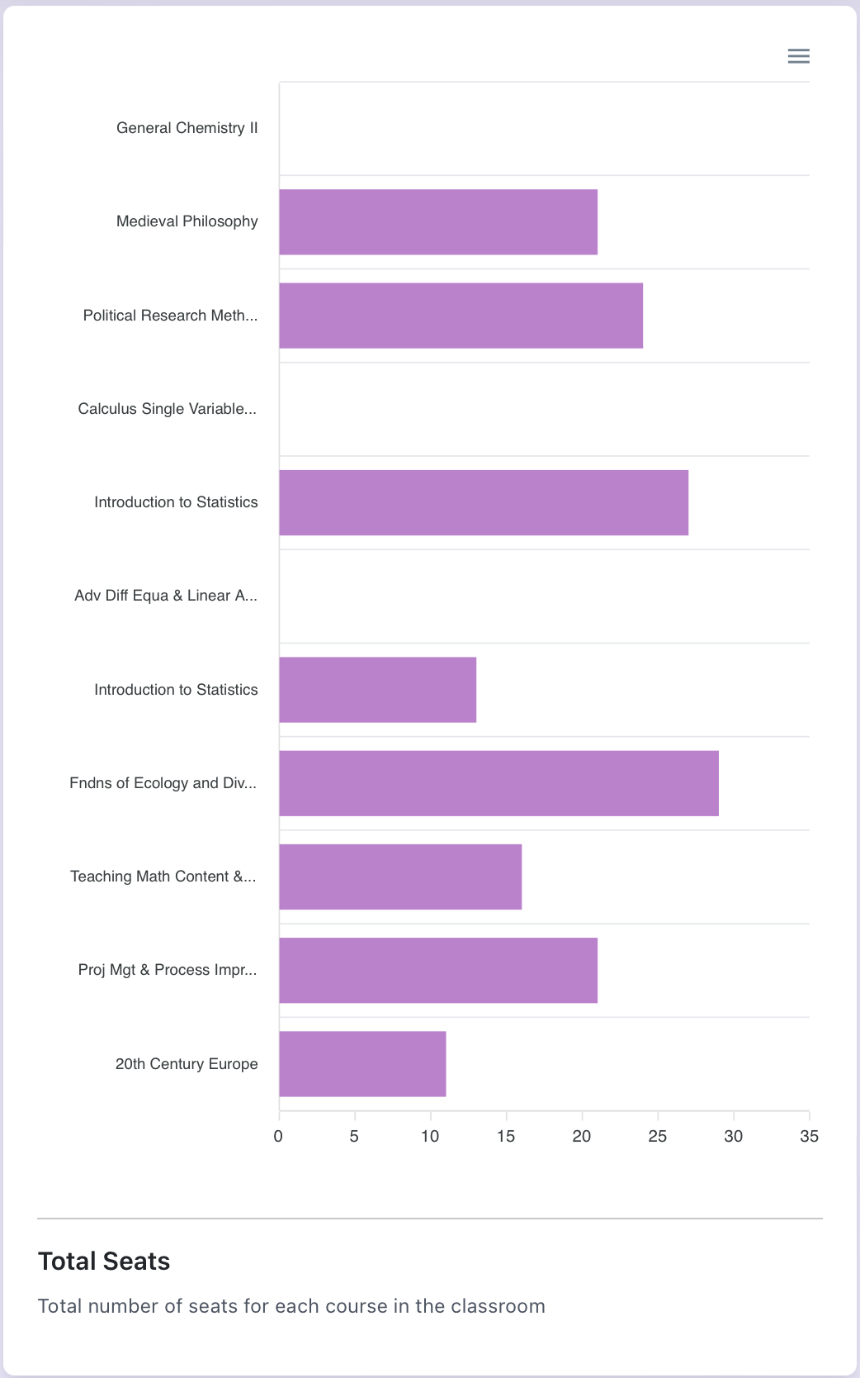

Finally, we have the total seats filled for each course, this can be used with the percentage of seats used to allow for a better overall view of the seats used in the classroom.

To view the selected classrooms schedule, click the “Load Classroom Schedule Button” in the top right corner.

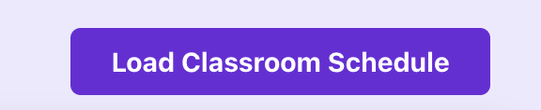

This will load the classroom schedule so it is easily viewable alongside the insights.

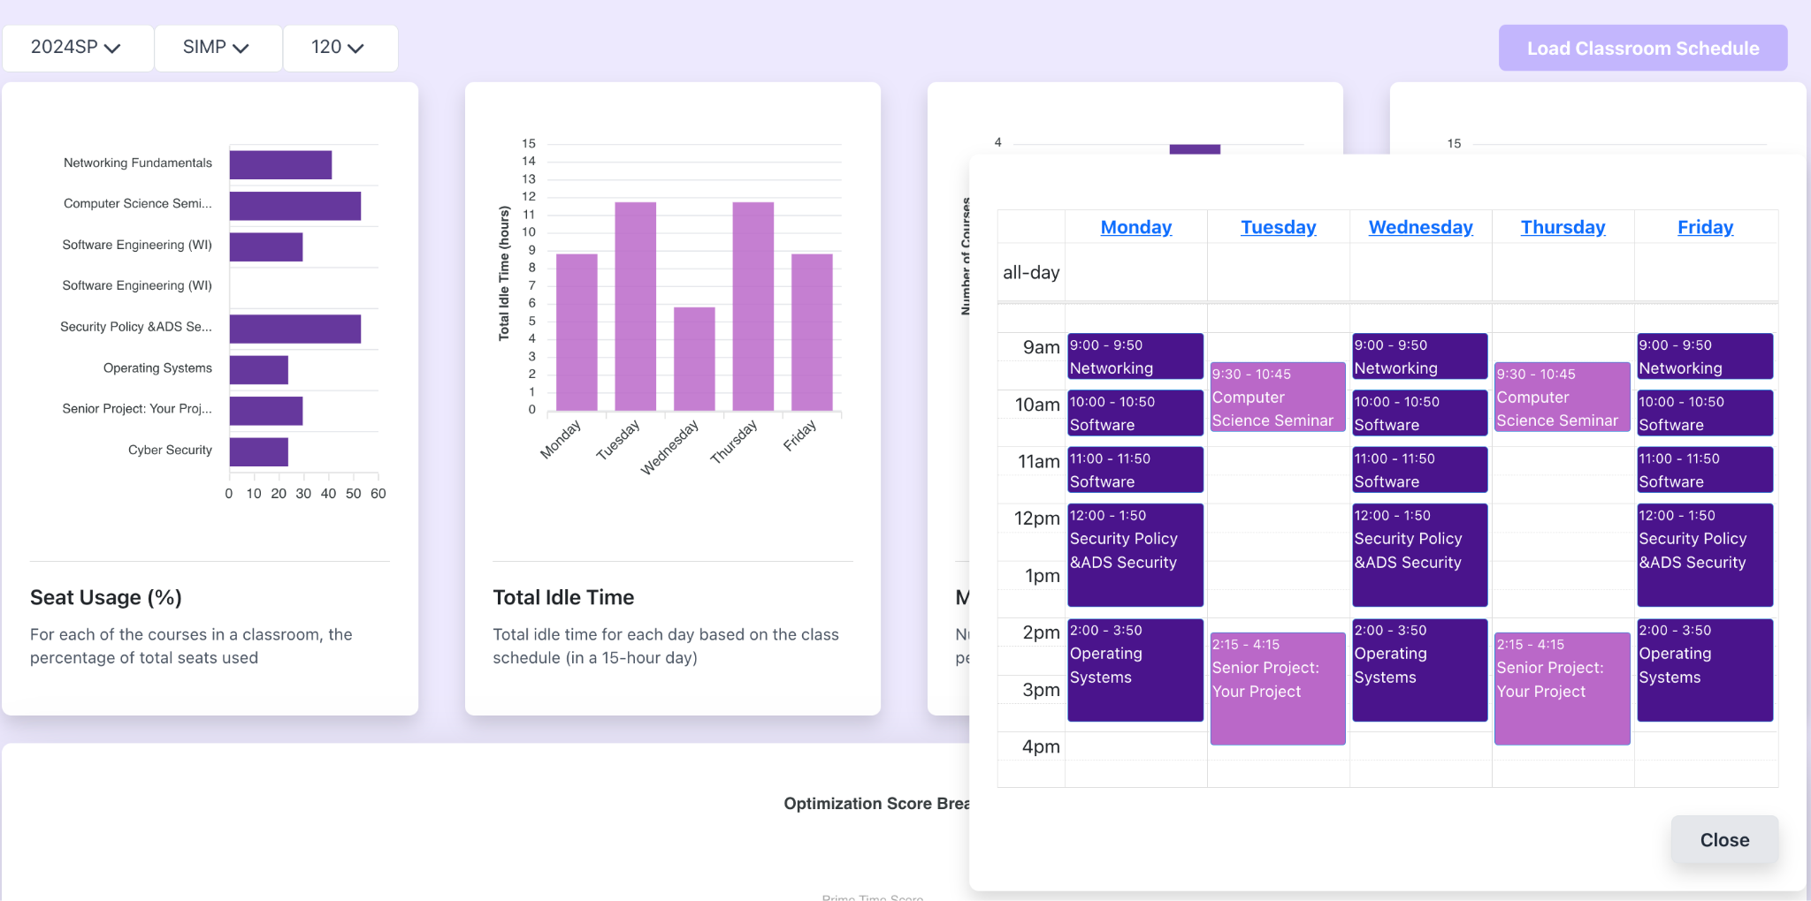

Further down the page is the classroom optimization score. This is a metric to understand how well the classroom is used. Each category is being graded on the metrics described in

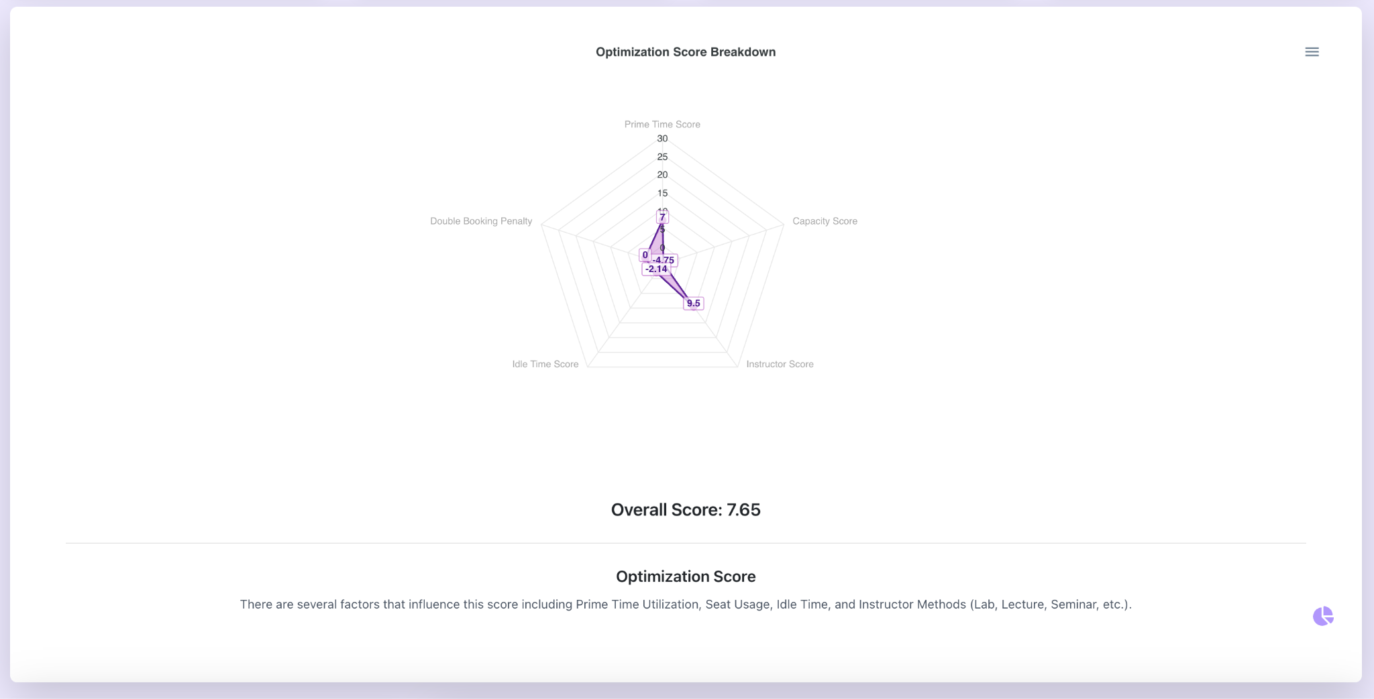

To view the details of the score, hover over the pie-chart icon in the bottom right. This will allow the scores of each category to be displayed and highlight the areas of the classroom that are not optimal.

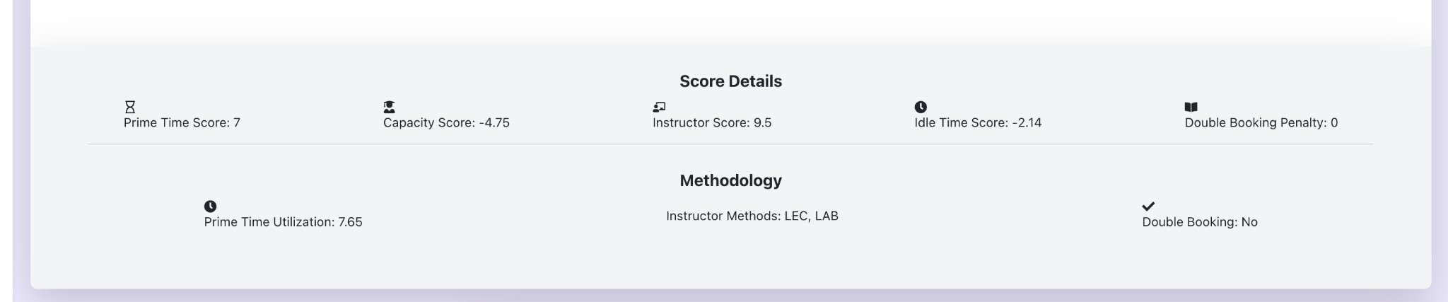

Further down the page, you will find details of the classroom on the left such as the amount of projectors in the classroom. You will also see a heat map of when the classroom is used as well as a listing of times the classroom is available.

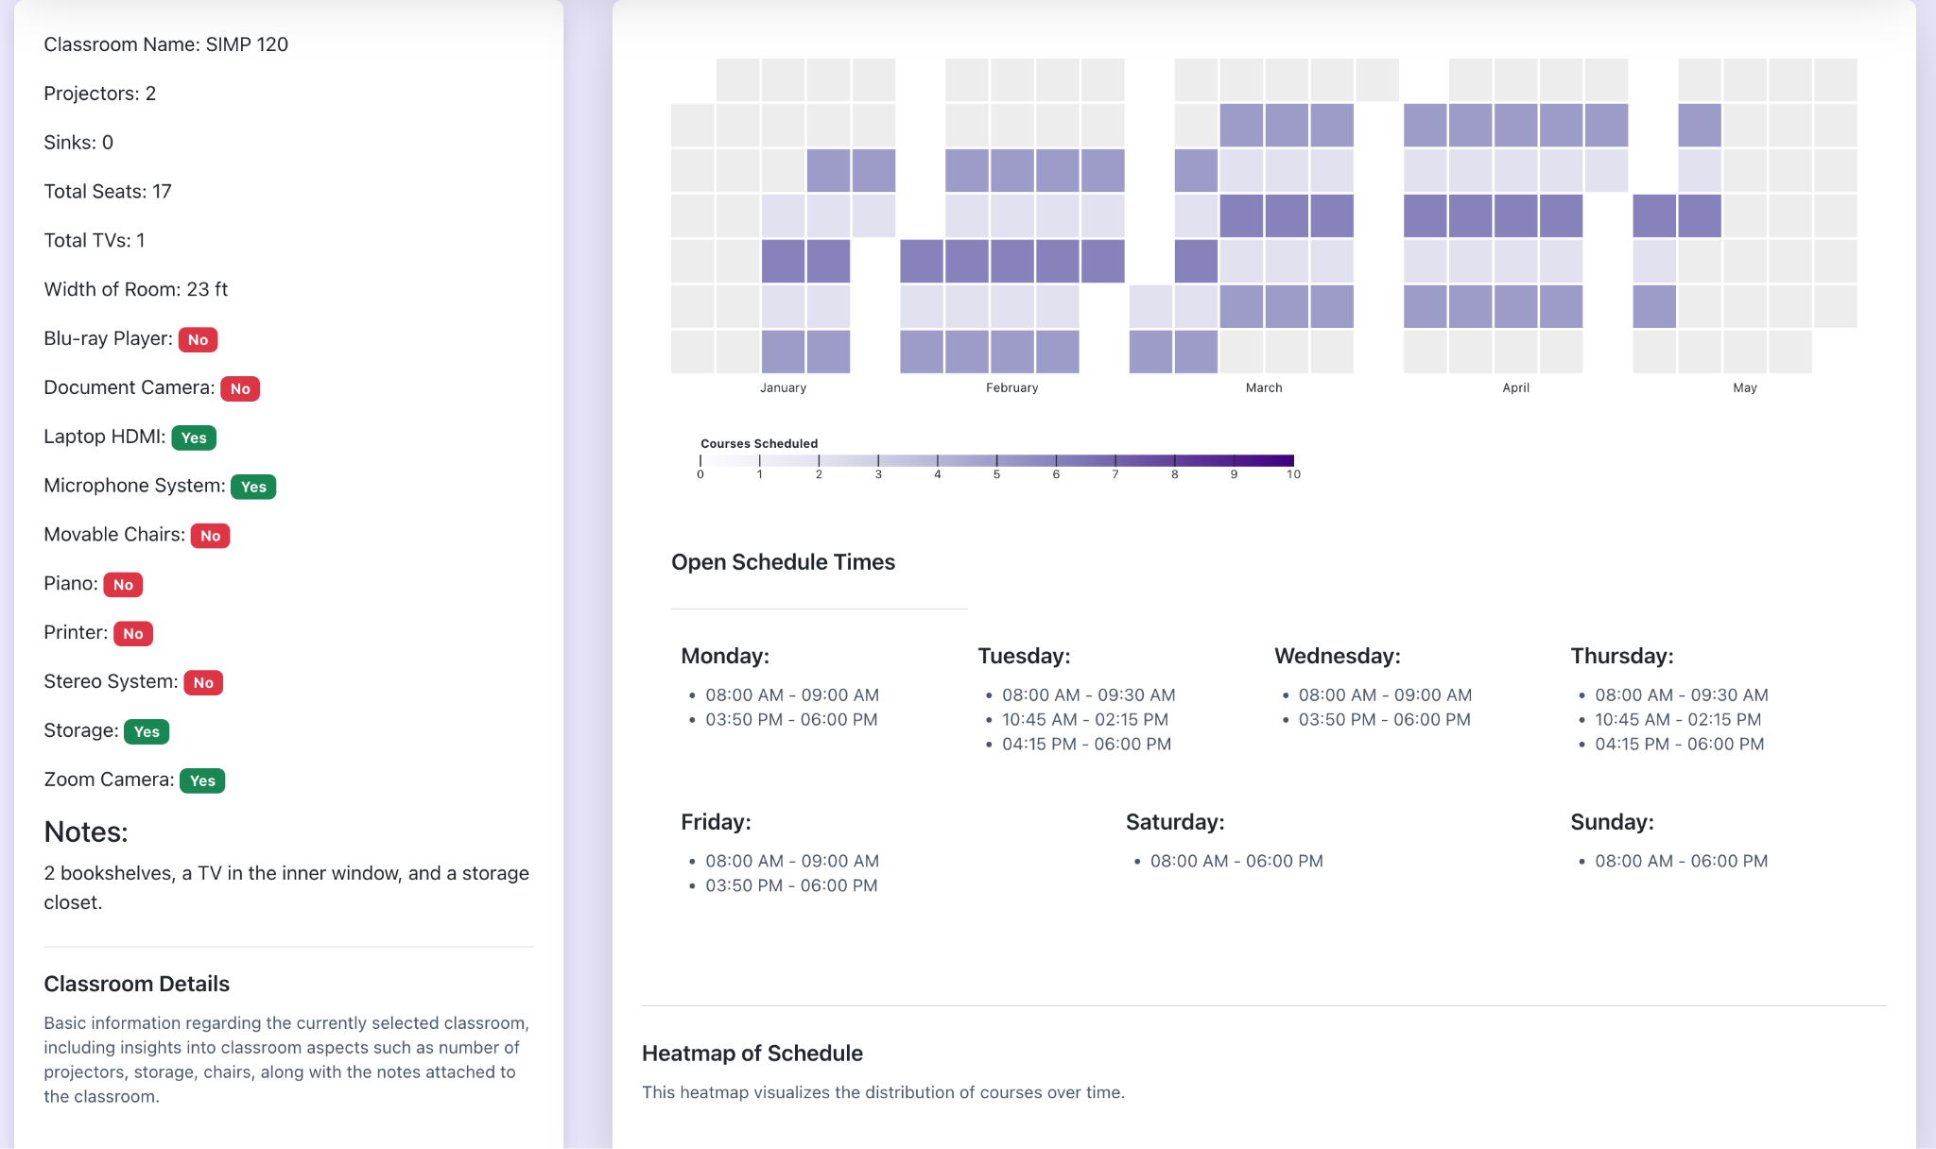

# Issues or Concerns

If you have any issues or concerns, please contact Nate Williams to facilitate an update.